**PRACTICAL - 7**

**Prepare the details Case Study on Design coding standards and guidelines for your respective “JobHunt” and justify which Software Quality Standards & Testing Tool will be suitable for your JobHunt.**

**Design coding standard:**

Code standards are rules, techniques, and guidelines to [create cleaner](https://community.codacy.com/t/tips-for-writing-clean-code/842), better readable, and more efficient code with minimal bugs and errors. In addition, they offer a uniform way for developers to build highly functional code. Remember that coding standards are not personal opinions; they are concrete rules determining your code’s programming style, procedures, and methods. Therefore, they need to be explicitly defined and made available to developers. Coding standards make sure all developers follow specified guidelines. As a result, every developer – even newcomers – can easily understand, debug and maintain the code. Ideally, your team’s source code should look like it was written by a single developer in a single session.

Some of the coding standards are given below:

1. **Limited use of globals:**  
   These rules tell about which types of data that can be declared global and the data that can’t be.
2. **Standard headers for different modules:**  
   For better understanding and maintenance of the code, the header of different modules should follow some standard format and information. The header format must contain below things that is being used in various companies:
   1. Name of the module
   2. Date of module creation
   3. Author of the module
   4. Modification history
   5. Synopsis of the module about what the module does
   6. Different functions supported in the module along with their input output parameters
   7. Global variables accessed or modified by the module
3. **Naming conventions for local variables, global variables, constants and functions:**  
   Some of the naming conventions are given below:
   1. Meaningful and understandable variables name helps anyone to understand the reason of using it.
   2. Local variables should be named using camel case lettering starting with small letter (e.g. localData) whereas Global variables names should start with a capital letter (e.g. GlobalData). Constant names should be formed using capital letters only (e.g. CONSDATA).
   3. It is better to avoid the use of digits in variable names.
   4. The names of the function should be written in camel case starting with small letters.
   5. The name of the function must describe the reason of using the function clearly and briefly.
4. **Indentation:**  
   Proper indentation is very important to increase the readability of the code. For making the code readable, programmers should use White spaces properly. Some of the spacing conventions are given below:
   1. There must be a space after giving a comma between two function arguments.
   2. Each nested block should be properly indented and spaced.
   3. Proper Indentation should be there at the beginning and at the end of each block in the program.
   4. All braces should start from a new line and the code following the end of braces also start from a new line.
5. **Error return values and exception handling conventions:**  
   All functions that encountering an error condition should either return a 0 or 1 for simplifying the debugging.
   1. On the other hand, Coding guidelines give some general suggestions regarding the coding style that to be followed for the betterment of understandability and readability of the code. Some of the coding guidelines are given below :
6. **Avoid using a coding style that is too difficult to understand:**  
   Code should be easily understandable. The complex code makes maintenance and debugging difficult and expensive.
7. **Avoid using an identifier for multiple purposes:**  
   Each variable should be given a descriptive and meaningful name indicating the reason behind using it. This is not possible if an identifier is used for multiple purposes and thus it can lead to confusion to the reader. Moreover, it leads to more difficulty during future enhancements.
8. **Code should be well documented:**  
   The code should be properly commented for understanding easily. Comments regarding the statements increase the understandability of the code.
9. **Length of functions should not be very large:**  
   Lengthy functions are very difficult to understand. That’s why functions should be small enough to carry out small work and lengthy functions should be broken into small ones for completing small tasks.
10. **Do not unnecessarily use statements that break the control flow of statements:**It is advised not to use jump, goto and function calls unnecessarily as it takes extra time for the processor to break the going flow, search for the mentioned statement, load those statements, execute them and then return to the previous calling function. Therefore, try to avoid such situations as much as possible.

,

1. **Contents of headers**:  
   The data that must be there in the header of each module has a pre-defined format. This usually includes the name of the module, data of creation, date of approval, developer’s or author’s name, synopsis, description of the module, description of the variables and functions defined in the module, etc.
2. **Use coding style that is easy to understand and is globally accepted**:  
   It is recommended that the coding style that is being followed must be easy to understand and should be similar tothat which is globally accepted or else it would be difficult for the user to understand it and also it would take time for the developers to develop a habit of following a completely new coding format.
3. **Trailing comments:**

**Trailing comments**are used to provide explanation of a single line of code. These comments are used to clarify the complex code. These also specify the function of the abbreviated variable names that are not clear. In some languages, trailing comments are used with the help of a double slash (//)*.*

1. **Inline comments:** Inline comments analyze the functioning of the subroutine, or key aspects of the algorithm shall be frequently used.
2. **Structured Programming:** Structured (or Modular) Programming methods shall be used. "GOTO" statements shall not be used as they lead to "spaghetti" code, which is hard to read and maintain, except as outlined line in the FORTRAN Standards and Guidelines.
3. **Turn daily backups into an instinct**

Multiple events can trigger data loss – system crash, dead battery, software glitch, hardware damage, etc. To prevent this, save code daily, and after every modification, no matter how minuscule it may be. Back up the workflow on TFS, SVN, or any other version control mechanism.

1. **When choosing standards, think Closed vs. Open**

Consider [CERT](https://www.perforce.com/blog/kw/what-is-cert) vs. [MISRA](https://www.perforce.com/resources/qac/misra-c-cpp). CERT emphasizes community cooperation and participation. It offers a coding standard that is freely available as a web-based wiki. With CERT, users can comment on specific guidelines – comments taken into account when the standards are reviewed and updated.On the other hand, MISRA is a set of C and C++ coding standards developed and maintained by the Motor Industry Software Reliability Association (MISRA). It is primarily considered the de-facto coding standard for embedded industries.

1. **File organization:** This includes file naming conventions and how the files will be organized on the file system.
2. **Coding conventions:** Consistent application of specific code-level conventions and the exclusion of considered poor form improve the quality of the code.
3. **White space**: Though it can be argued to be less critical than the other items listed here, a consistent usage of white space as indentation and blank lines also improves readability.
4. **One statement per line There shall normally be no more than one statement per line**: This includes control statements such as “if” and “end” statements. When a single operation or expression is broken over several lines, break it between high-level components of the structure, not in the middle of a sub-component. Also, place operators at the ends of lines, rather than at the beginning of the next line, to make it clear at a glance that more is coming.
5. **File Naming Guideline:** A consistent naming convention for files and for directories shall be developed and used on a per project basis. A file naming convention makes project files easily distinguishable from other projects, and it helps associate different file types within the same project. Directories and subtrees can be used to link portions of a project together.
6. **Organized collection of information that is systematically organized for easy access and analysis:**

Table names should start with TBL. For example, TBL_STUDENT.

If table names contain one word, field names should start with the first three characters of the name of the table. For example, STU_FIRSTNAME.

Every table should have a primary key. Long data type (or database equivalent) should be used for the primary key.

1. **Proper explanation of all types of errors should be mentioned**

For example, 0102: null pointer exception, where 0102 indicates the error code and null pointer exception is the name of the error.

1. **Proper class name convections should be given**

All class names should start with the abbreviation of each group. For example, AA and CM can be used instead of academic administration and course management, respectively.

**Standard use for JobHunt:**

**ISO**

The [International Organization for Standardization (ISO)](http://www.iso.org/) is a worldwide federation of national standards bodies from more than 160 countries, one from each member country. ISO is a non-governmental organization established in 1947 and based in Geneva. Its mission is to promote the development of standardization and related activities in the world with a view to facilitating the international exchange of goods and services, and to developing cooperation in the spheres of intellectual, scientific, technological and economic activity. ISO's work results in international agreements which are published as International Standards and other types of ISO deliverables.

**ISO 9000 is suitable for JobHunt.**

* **User focus:** Make sure that easy to understand for user. Also give better user experience.
* **Improvement:** Provide Feedback facilities to improve user requirements and some new features.

**Table 7.1 Software Quality Parameters**

| SR No. | Parameters |
| --- | --- |
| 1. | Reliability |
| 2. | Portability |
| 3. | Security |
| 4. | Understandability |
| 5. | Usability |

* **Reliability :**JobHunt ensures reliability by ensuring that when a user using website or app all feature are work properly and smoothly. It also work on make efficient software. Who will be done? Developer team done
* **Portability:** JobHunt can be used on android and IOS and also on any browser

Who will be done?

Developers will be done

* **Security:** JobHunt offers security by authentication and authorisation of users when they login.
* **Understandability:** JobHunt can be understood by any user that it’s an easy to explore jobs and easy to apply in jobs.
* **Usability:** JobHunt is easy to use app/website hence it is very user friendly.

**Table 7.2 Jira Tools**

|  |  |
| --- | --- |
| Sr No. | Testing Tools |
| 1. | Selenium |
| 2. | Jira |
| 3. | Accelq |
| 4. | CrossBrowser Testing |
| 5. | NetSparker |

* **Selenium**

Selenium is one of the most popular software testing tools. It specifically designed to support [Automation Testing](https://www.guru99.com/automation-testing.html) of functional aspects of app based applications, a wide range of platforms and browsers .It is one of the best qa tools which offers the support for parallel test execution that reduces the time taken in executing parallel tests .Selenium needs very few resources when compared to other manual testing tools.

How can Selenium be used in JobHunt?

JobHunt has a web application  and has many components so parallel testing (Parallel Testing is a software testing type in which multiple versions or subcomponents of an application are tested with the same input on different systems simultaneously to reduce test execution time. The purpose of parallel testing is finding out if legacy version and new version are behaving the same or differently and ensuring whether new version is more efficient or not.) is required to reduce time and efficiency after every update.

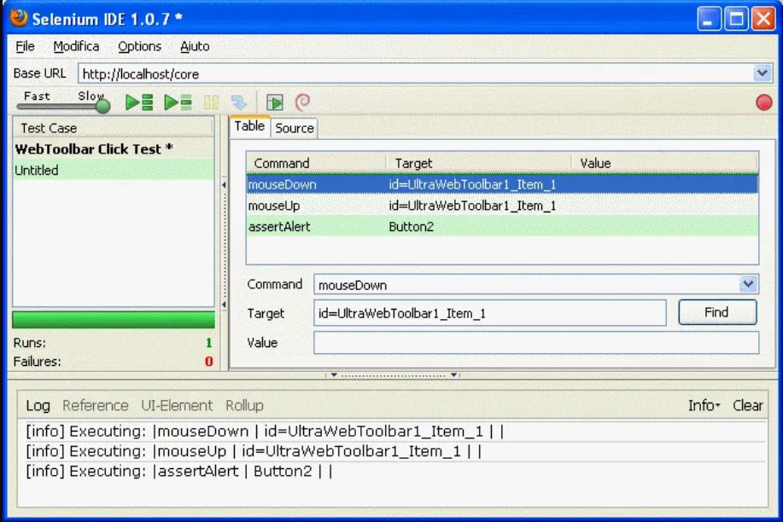

**Application:**

* Open Source and Portable
* Combination of tool and DSL
* Easier to understand and implement
* Less burden and stress for testers
* Cost reduction for the Business Clients
* **Jira**

JIRA is a [defect tracking tool](https://www.guru99.com/top-20-bug-tracking-tools.html) which is used for defect/issue tracking as well as project management. This tool is not only used for recording, reporting but also integrated directly with the code development environment .JIRA Query Language helps to create quick filters with a single click Possible to create custom workflows of any size which is helpful to build, test, and release software .Install plug-and-play add-ons from The Atlassian Marketplace to fit all types of cases.

How can Jira be used in JobHunt?

Testing team can use it to do preventive software maintenance by tracking defects in advance and also it has many kinds of users so applying filters will be very useful.

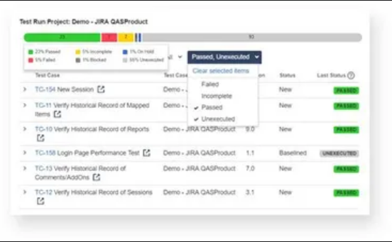

**Application:**

* Used for requirements & test case management.
* Used for Agile team.
* Used for project management teams.
* Applied for Software development teams.
* Jira is used for task management.
* **Accelq**

[ACCELQ](https://guru99.live/gQZvqZ) is an AI-powered Codeless Test Automation platform on the cloud that seamlessly automates Web UI, API, Mobile, and Desktop. ACCELQ is proven to speed up automation development by 3 times and bring down the maintenance by 70% that translates to over 50% of cost savings and enables alignment with Continuous Delivery.

How can Accelq be used in JobHunt?

JobHunt has a mobile application too and many modules so this too can help us to test without writing code in a speedy way.

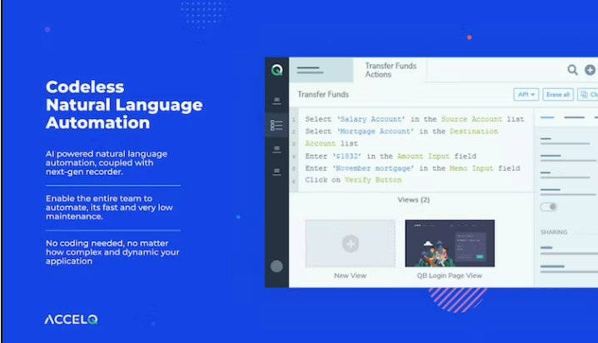

**Application:**

* Catch Bugs
* Organize and Allocate
* Track Bugs and Solve
* Getting Informed

### Cross Browser Testing

Cross-browser testing helps to ensure that website or web application functions correctly in various web browsers. With the help of this tool, it is possible to run parallel automated tests, compare screenshots, and remotely debug real desktop and mobile browsers .It is one of the qa testing tools that can run Numerous Tests on Multiple Devices At One Time Easily run automated tests against real iOS, Androids, & other desktop browsers It allows running testing frameworks like WebDriver.IO, and Night watch for superior quality and speed

How can Cross Browser Testing be used in JobHunt?

JobHunt has a web application so cross browser testing is a must do testing so with this tool we can ensure that it works in the same way in all browsers in order to ensure quality and speed.

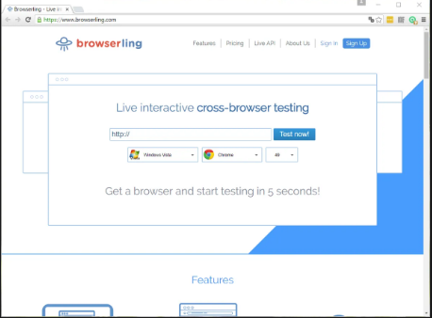

**Application:**

* Customer Support and Technical Support
* Cloud-Based
* Simple User Interface
* Test on Browsers
* **Net sparker**

Net Sparker is a security testing tool which automatically scans websites, web applications and web services for vulnerabilities. It is the only scanner that automatically identifies and verifies vulnerabilities with a proof of concept. Affordable and Maintenance Free Web Application Security Solution. It is fully Configurable Online Web Vulnerability Scanner. This security testing tool easily Integrate Web Security Scanning In SDLC ,it supports Enterprise Level Collaboration

How can Net sparker be used in JobHunt?

JobHunt needs to ensure security of customer’s data . This tool can help us to pinpoint all security backlogs and to provide a more secure platform for users.

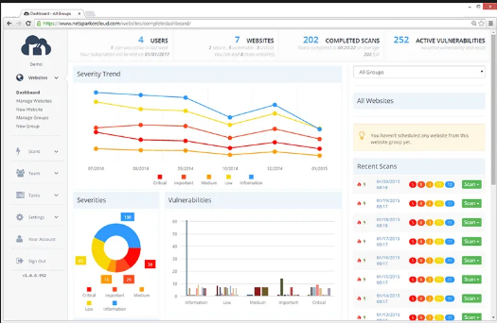

**Application:**

* Dashboard & Reporting Alerting API / Integrations
* Risk Analysis
* Vulnerability Assessment Security Auditing
* Analysis
* Reporting and Analytics Issue Tracking Static Code Analysis Vulnerability Scan
* Testing
* Manual Testing Test, Automation Compliance ,Testing Black-Box, Scanning Detection Rate

**References:**

[1] <https://www.perforce.com/resources/qac/coding-standards>

[2] <https://www.geeksforgeeks.org/software-engineering/>

[3] <https://www.guru99.com/testing-tools.html>

[4]<https://www.accelq.com/?utm_source=guru99&utm_medium=paid+listing&utm_campaign=guru99+testing+tools>

[5] <https://www.techtarget.com/whatis/definition/header>

[6] <https://kedar.nitty-witty.com/blog/software-quality-attributes-parameters-explained>

[7] <https://asq.org/quality-resources/iso-9000>

[8] https://www.iso.org/standard/29280.html

[9]<https://standards.iteh.ai/catalog/standards/iso/1906b725-53f7-449d-8843-c8a51940f801/iso-9000-2000>

[10] <https://www.javatpoint.com/software-testing-tools>

[11][https://www.browserstack.com/guide/coding-standards-best-practices#:~:text=Think%20of%20coding%20 standards%20as%20a%20 set%20 of,highly%20 functional%20code.%20 Advantages%20of%20 implementing%20Coding%20 Standards](https://www.browserstack.com/guide/coding-standards-best-practices#:~:text=Think%20of%20coding%20standards%20as%20a%20set%20of,highly%20functional%20code.%20Advantages%20of%20implementing%20Coding%20Standards)

[12]  <https://www.geeksforgeeks.org/coding-standards-and-guidelines/>